**→ No reference image quality assessment using BRISQUE :**

→ Full form of BRISQUE is blind/reference less image spatial quality evaluator.

→ It measure the quality of image and give the score of image according to the quality of image .

→ Lower score means higher the quality of that image

→ Higher score means lower the quality of that image

**(1) Read our image :**

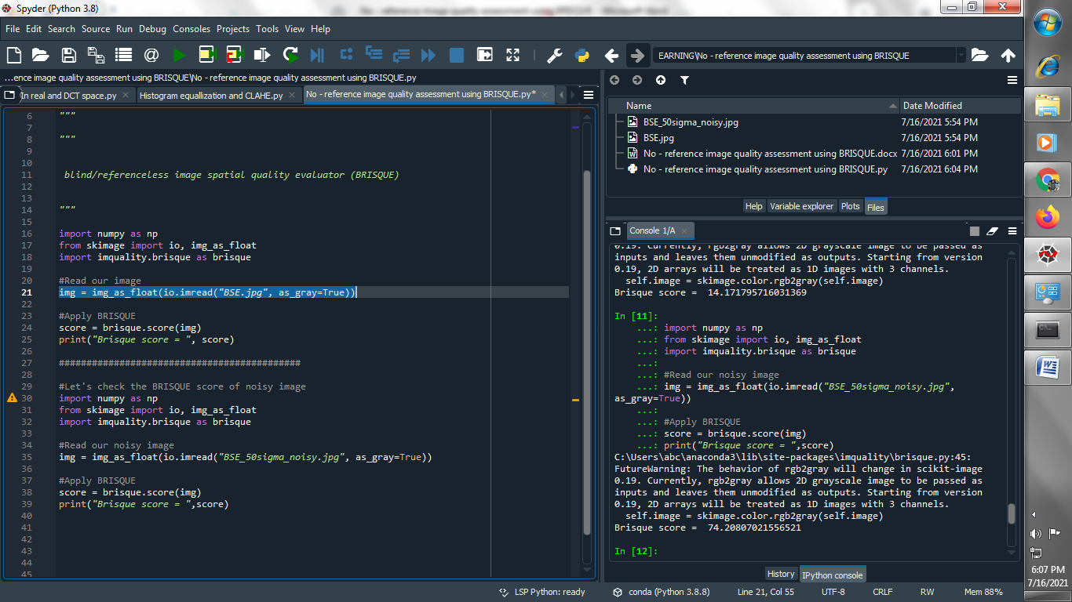

**(2) Apply BRISQUE :**

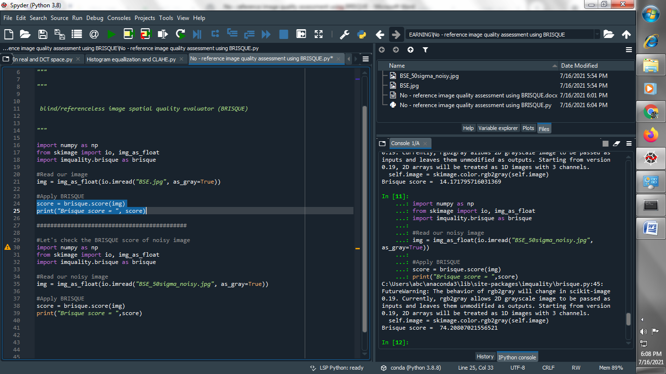

**Output :**

**Image :**

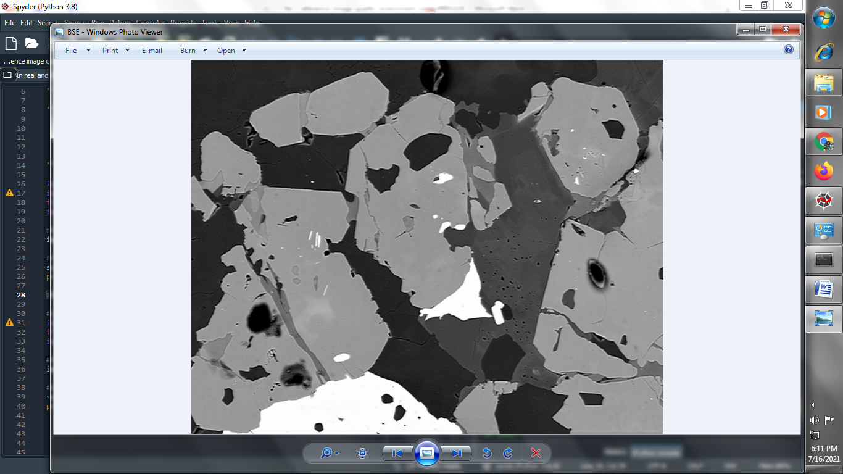

**BRISQUE SCORE :**

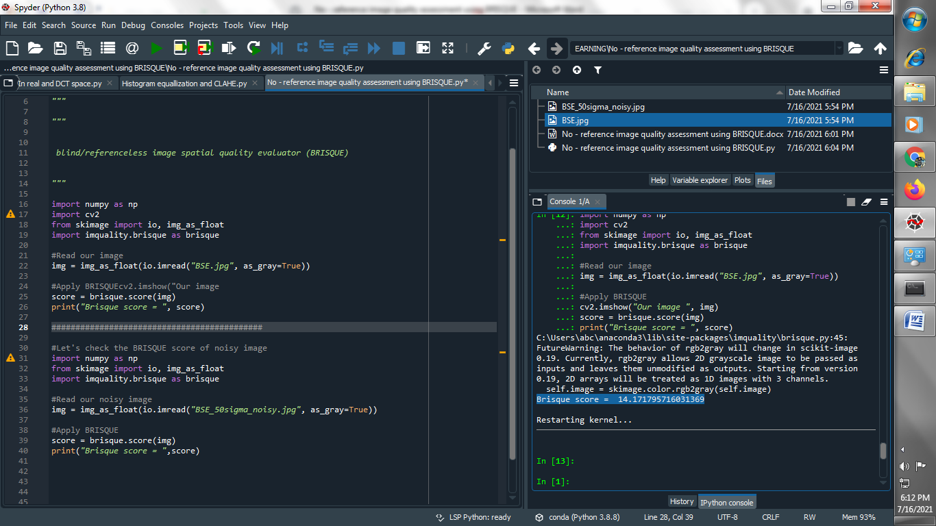

**→ Let's check the BRISQUE score of noisy image :**

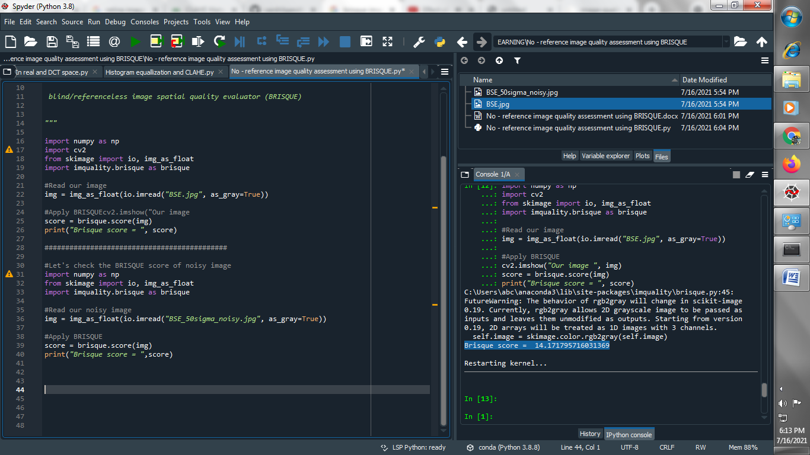

**Output :**

**Image :**

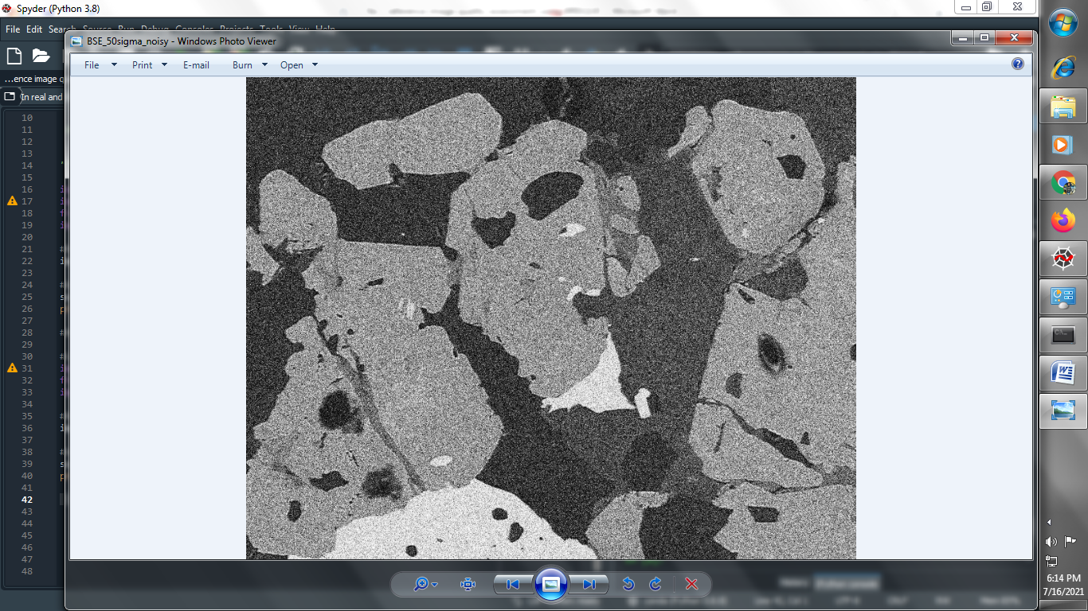

**BRISQUE SCORE :**

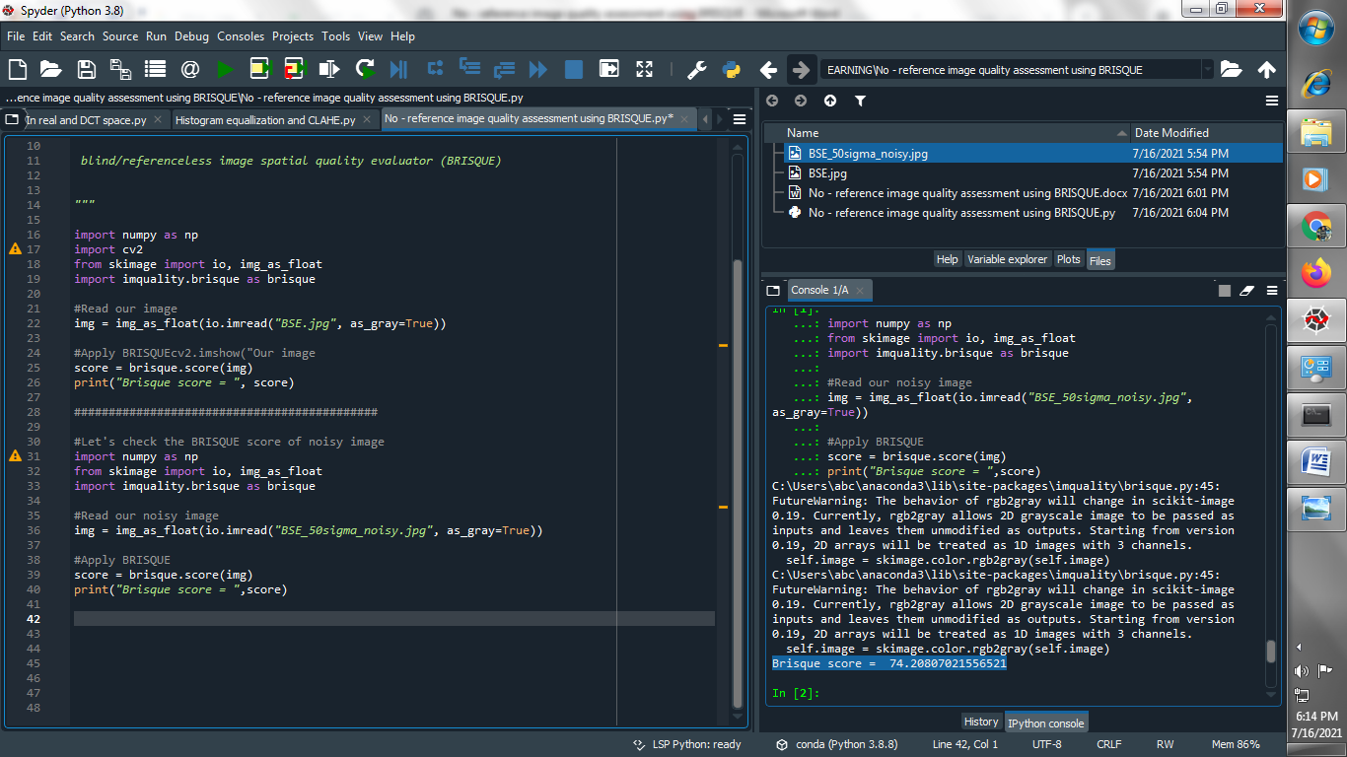

**→ Now let us check BRISQUE scores for a bunch of blurred images and also check PSNR (Peak signal noise ratio) :**

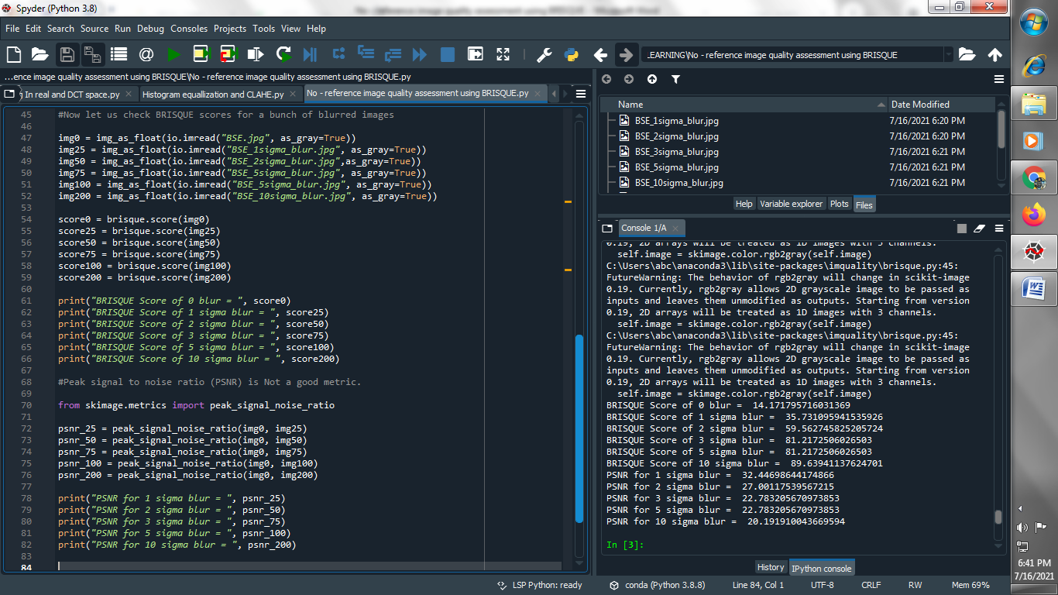

**Output :**

